Deployment Manual

* Download the compressed project from the given
* GitHub link: Link: [GitHub Link - Evoting Application](https://github.com/Arpitja112/TECHBEE_JFM22_APPS_FS_JAVA_5-EVOTING-APPLICATION.git)
* Open STS and import the downloaded file.
* Go to your application properties and change the credentials according to your system.
* The port number we have given is 9899.
* Run the project as spring boot application as shown in the picture below (Go inside EvotingApplication class and start running from there).

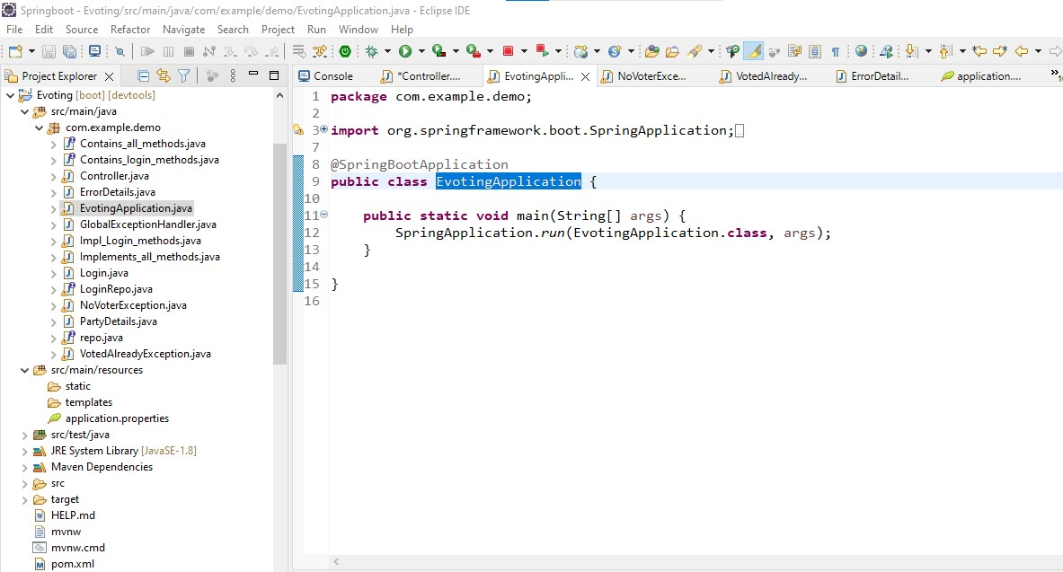

* Once, it shows login EvotingApplication has started in the console.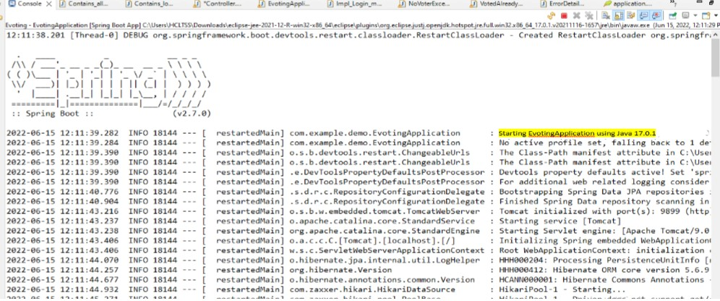
* ***Download the angular file from the given GitHub link and run the file with “npm start”. Once it gets loaded(***<http://localhost:4200/homepage>)***, Home page of the site gets opened up. Click on Login.***

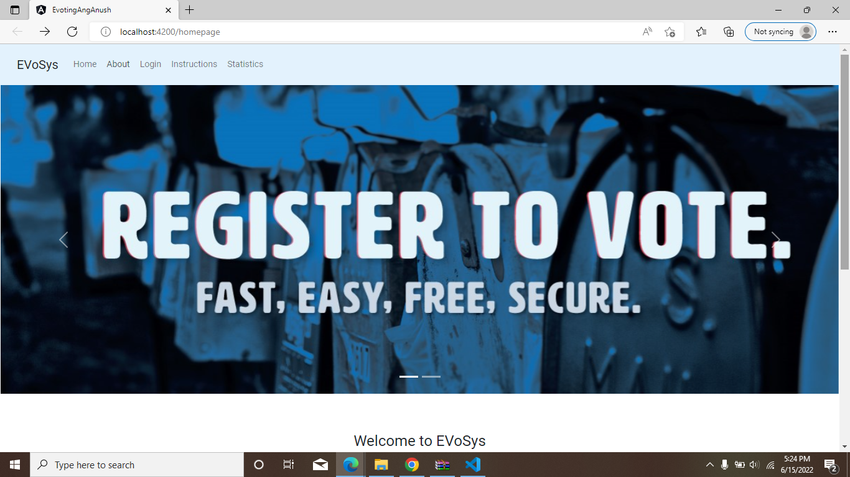

* ***To login to admin account, Enter Gmail Id as Admin@gmail.com and password: admin. And click login.***

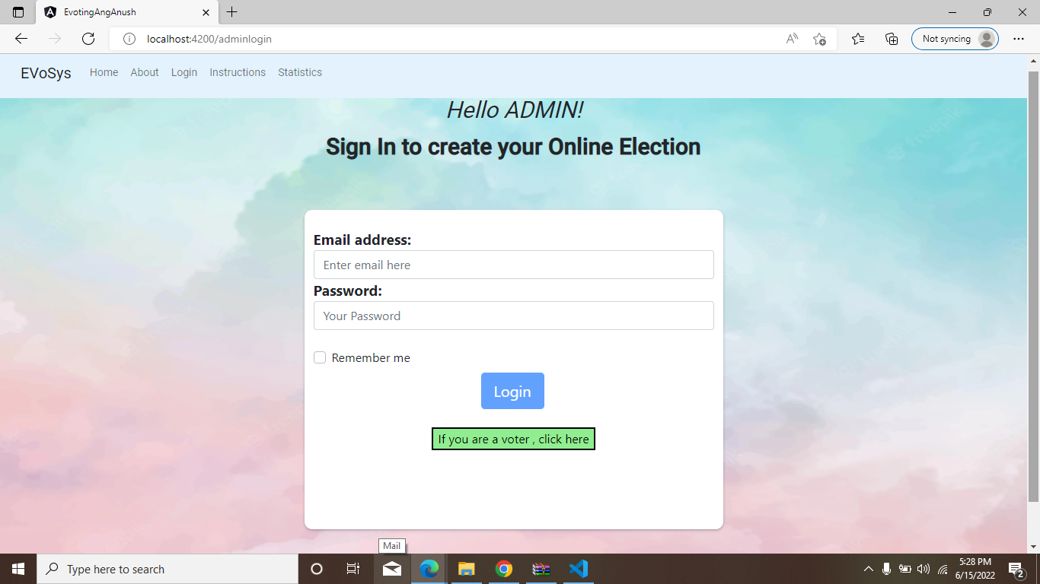

* ***Now the admin page open’s.***

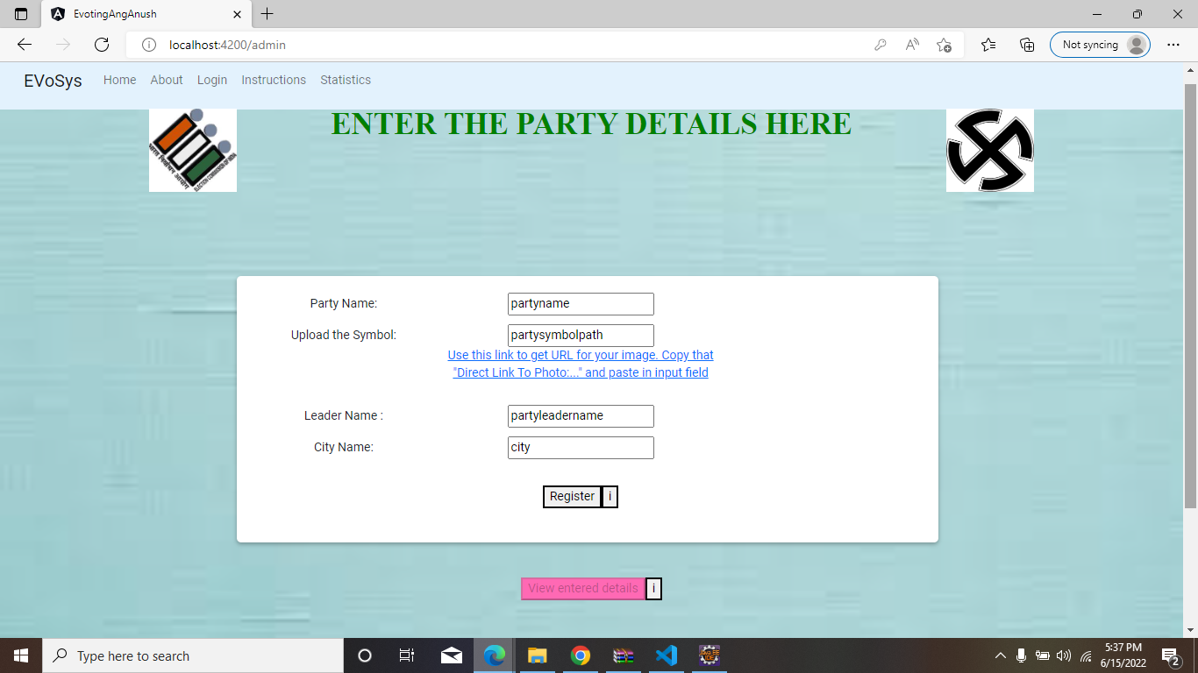

* ***Enter the party details as you want in your election.***
* 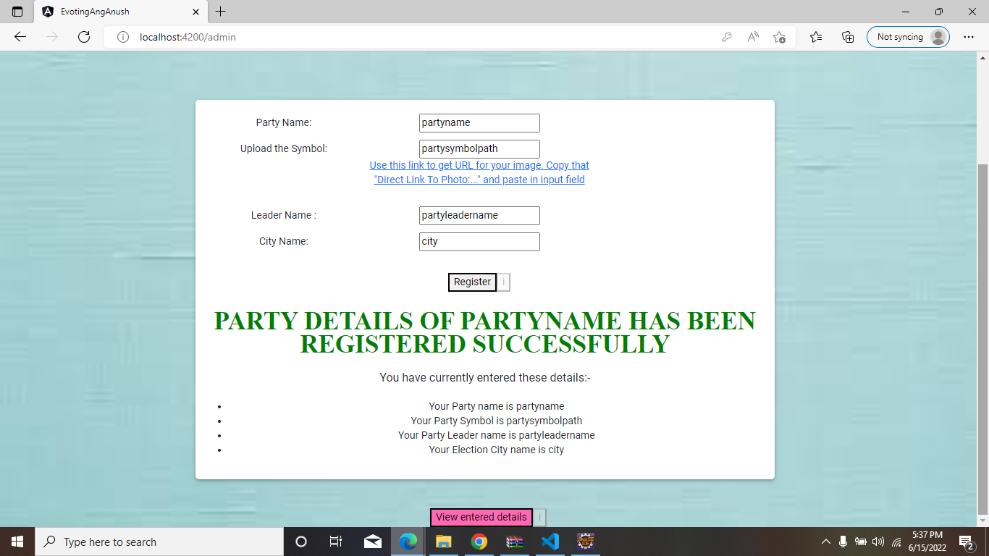
* ***Entered party details will be displayed as below***

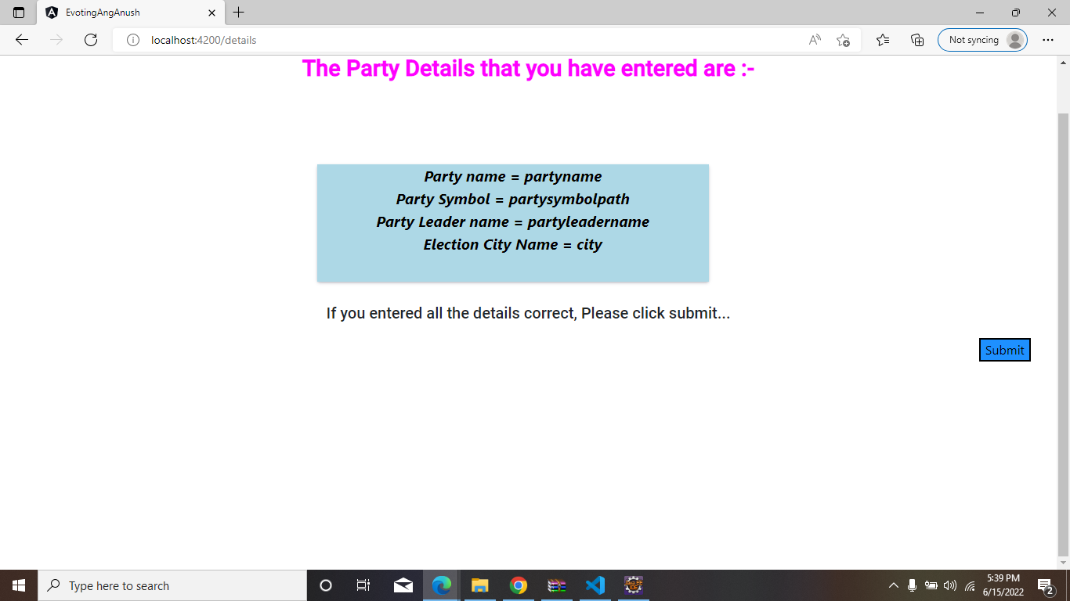

* ***You can log out and go to Home page.***



* ***Login as voter with the registered E-mail Id. As shown below: -***
* 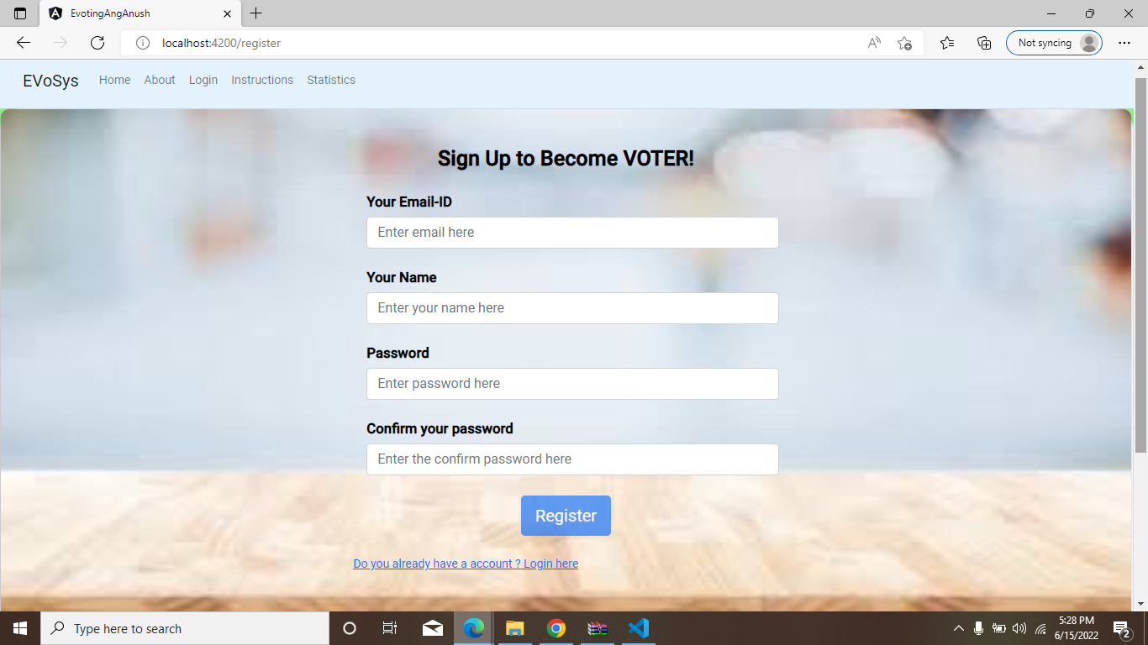
* 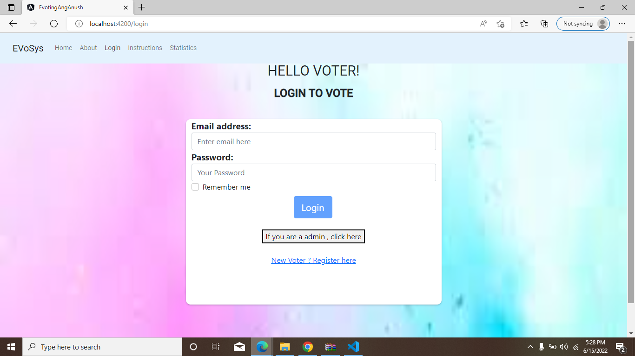
* ***Now voter page will be visible with the details entered by the admin.***

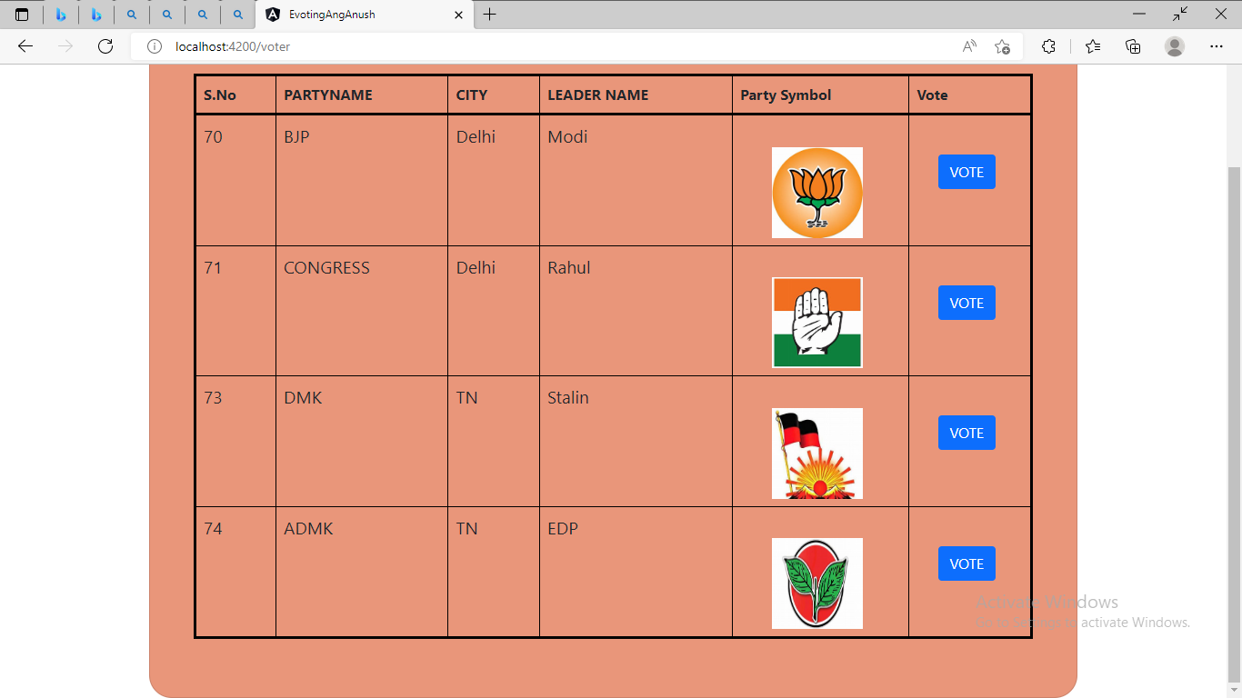

* ***After voting for the party that you want. You can check for the leading party.***

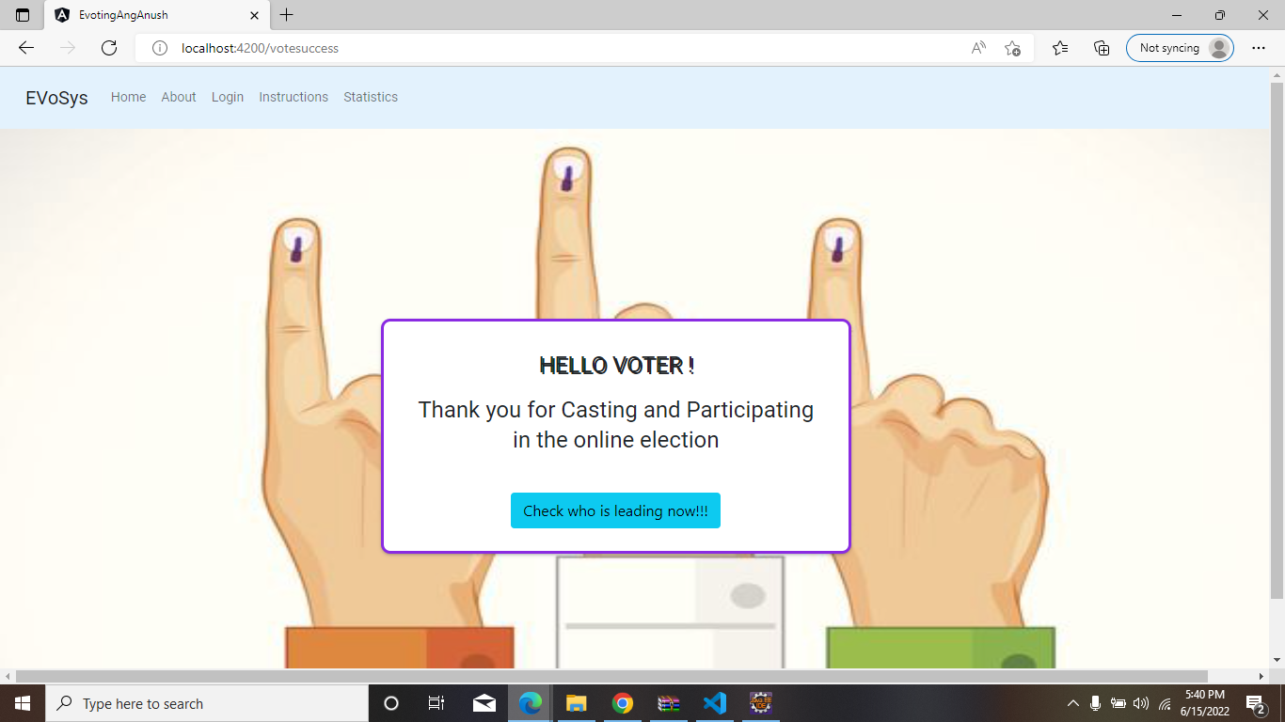

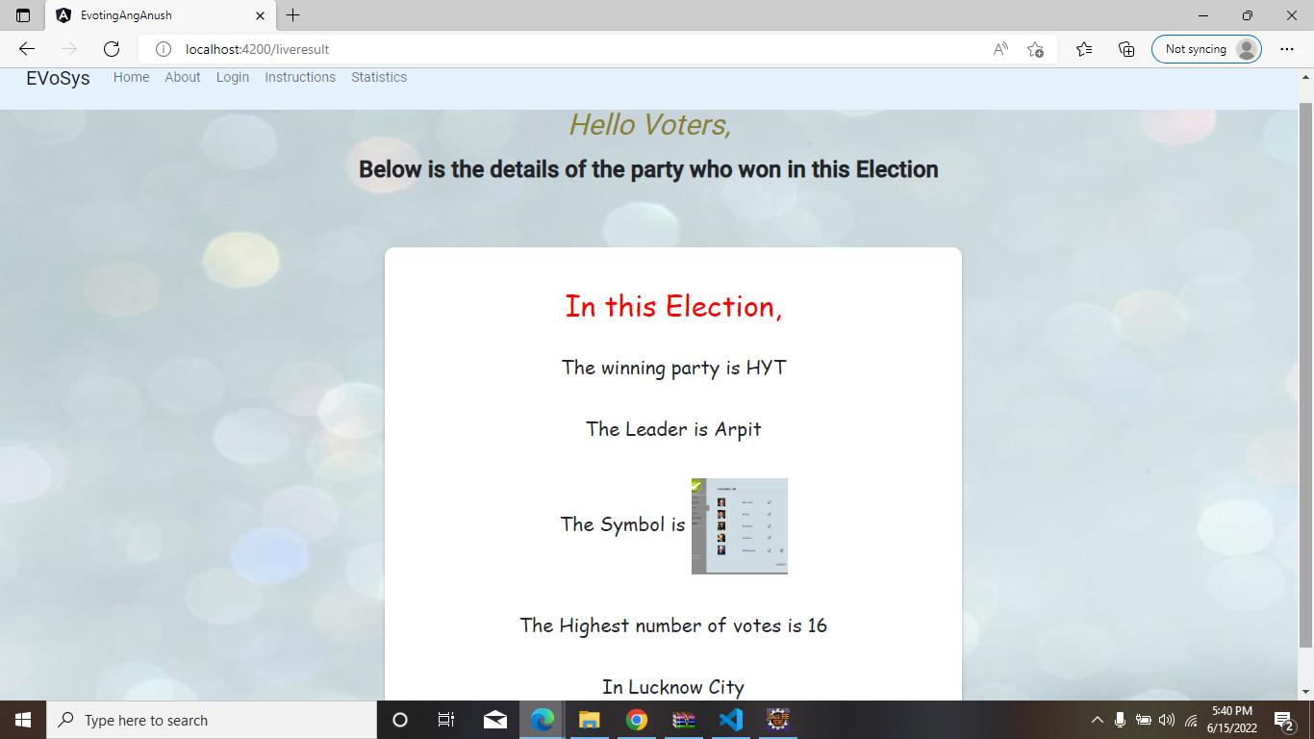

* ***After that you can logout and return to the Home page.***